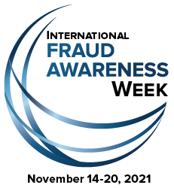

Sample Proclamation:

WHEREAS: This year marks the observance of International Fraud Awareness Week, which is set aside to raise awareness about the impact of fraud upon our society; and

WHEREAS: The Association of Certified Fraud Examiners, an organization dedicated to the mission of reducing the incidence of fraud worldwide, estimates that a typical organization loses five percent of its revenue each year to fraud; and

WHEREAS: State, local, and federal governments are frequent targets of fraud; and

WHEREAS: Instances of fraud in state government undermines the good work and reputation of all state employees who complete their assigned duties with integrity and honesty, and decreases confidence in public officials; and

WHEREAS: Fraud against the State of [INSERT STATE] is a burden borne by its citizens and businesses in the form of increased costs; loss of public revenues and resources; and increased expenses associated with the investigation, prosecution, and eventual incarceration of individuals who commit fraud; and

WHEREAS: Tips received from employees are consistently the greatest source by which frauds are detected; and

WHEREAS: Increasing employee awareness of fraud, including the magnitude of the problem, and educating employees about fraud prevention, detection, and reporting techniques, is critical for reducing the incidence of fraud against and within [INSERT STATE] state government.

NOW, THEREFORE, I, [INSERT GOVERNOR], Governor of [INSERT STATE], do hereby proclaim the week of November 14-20, 2021, as: International Fraud Awareness Week.

